**Week 8:**

**Task 14: Create a University Notes App.**

**Create a Notes/tutorials APP in Android on a particular subject, like HTML Notes App, or Android**

**Notes App with Web view as discussed in the following requirements.**

**Requirement: App with Notes on HTML only. Complete App. With Main Screen Showing**

**Various Chapters.**

**Then Second Screen Should show each topic inside the Chapter. Then Finally each topic notes**

**should appear. The final notes screen should contain, Syntax, Example Code, and Final Output.**

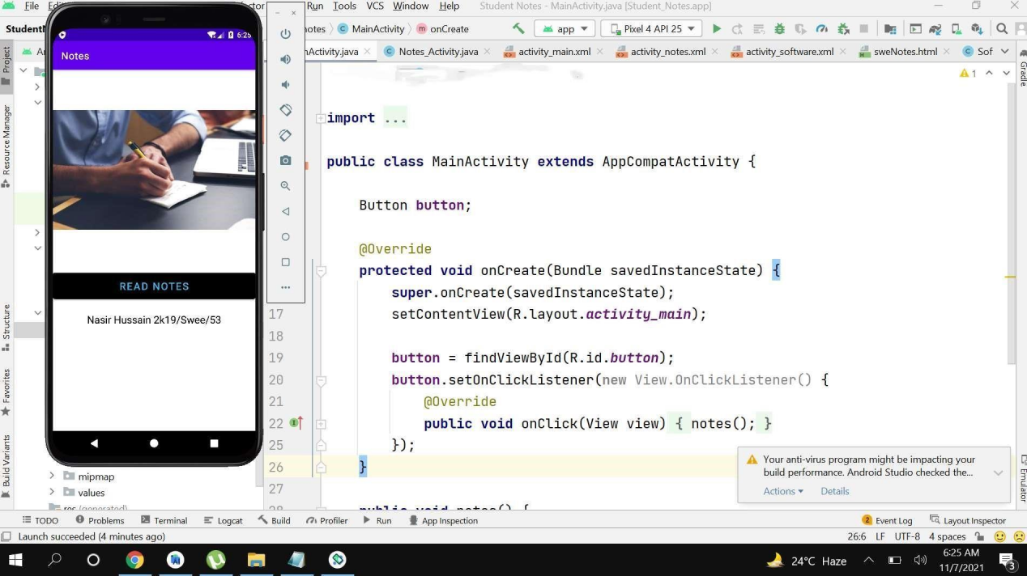

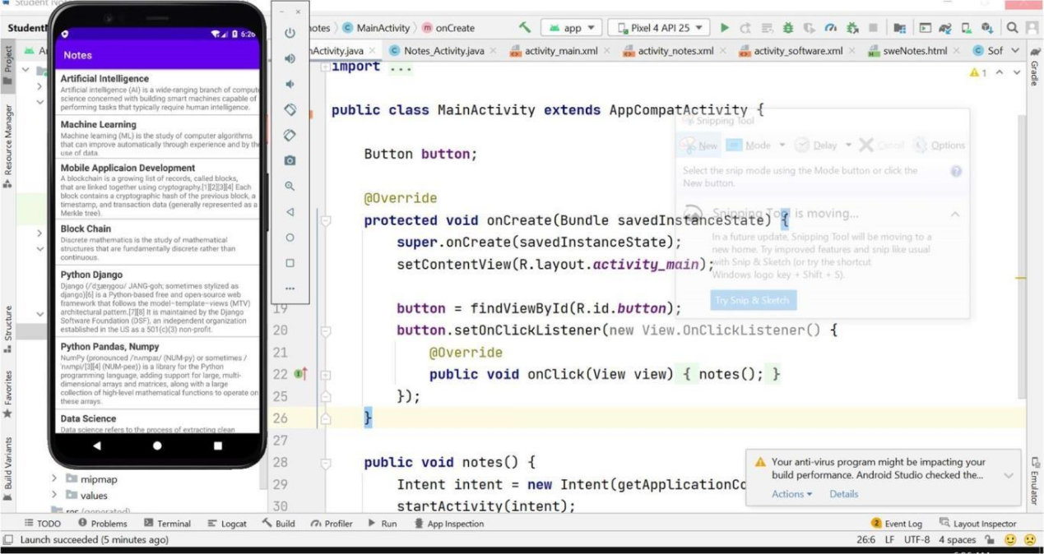

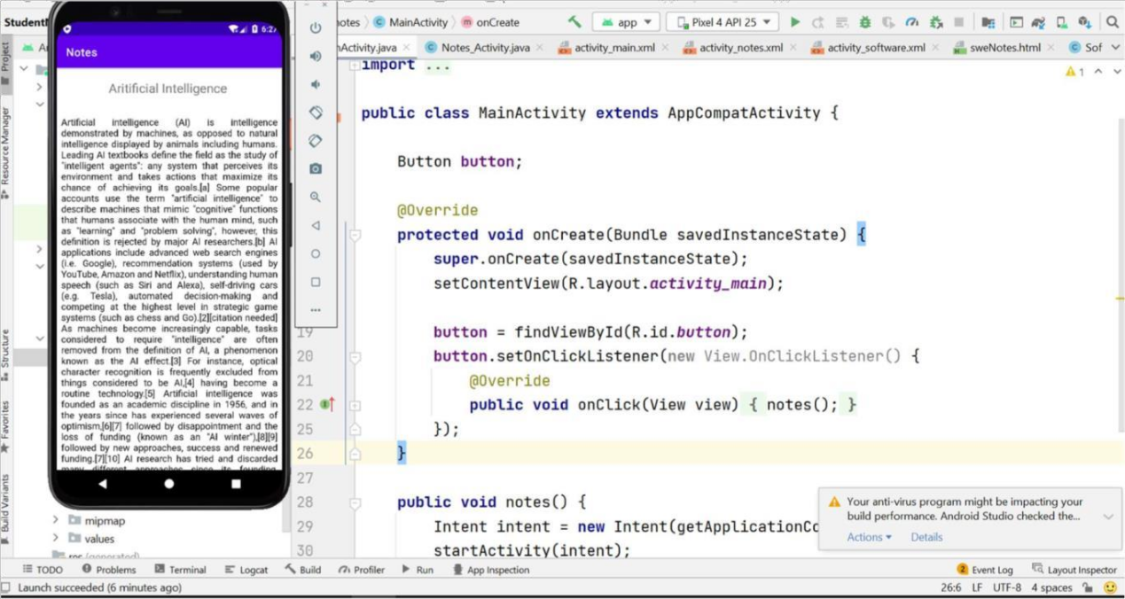

**Week 9:**

**Task 7:** Create a basic app to demonstrate Android Activity Life Cycle. Watch

the following lectures

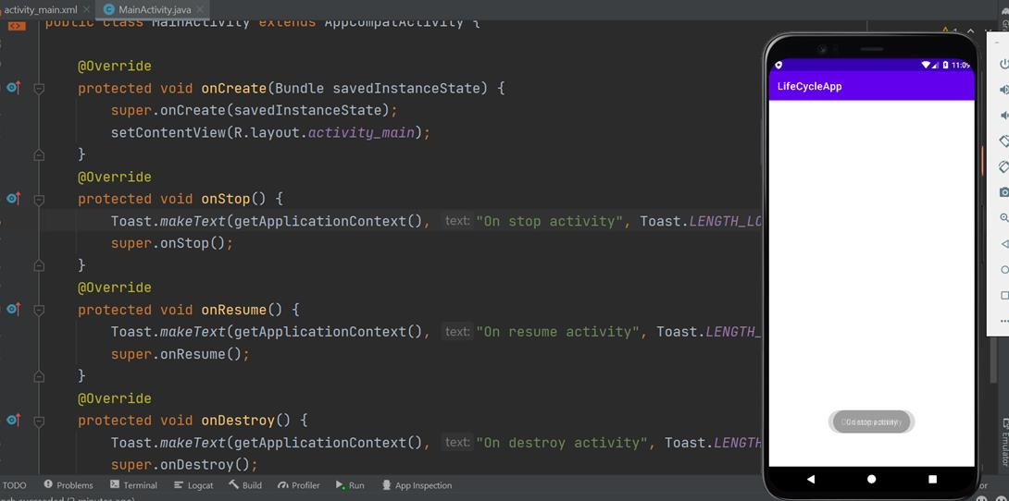

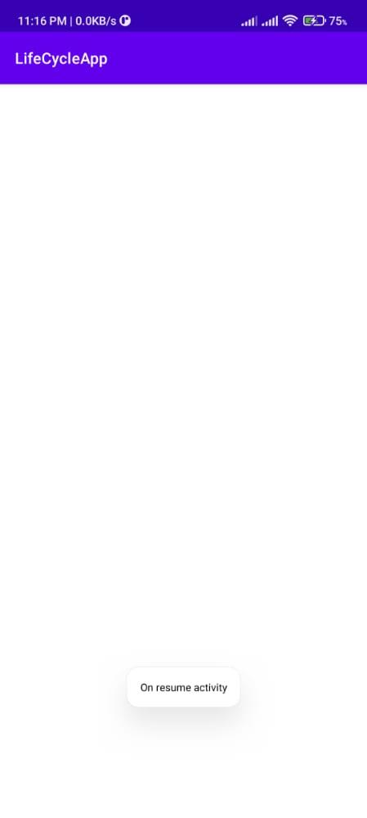

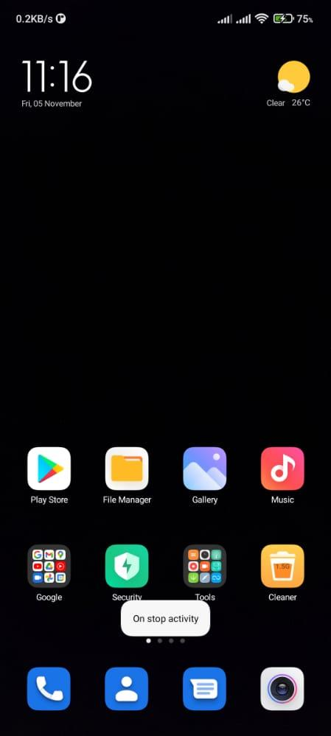

Week 10:

Task 18: Create a Tourism Guide App for any location

Create a simple app called Tourism Guide with at least 6 cities, their Famous places to visit,

restaurants etc. (or you can choose any other country or city or place).

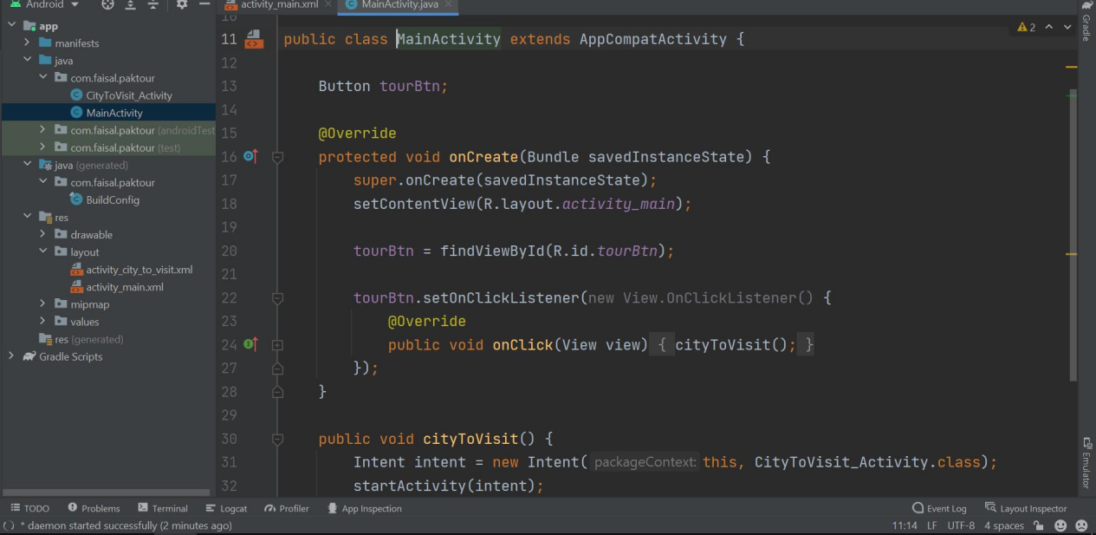

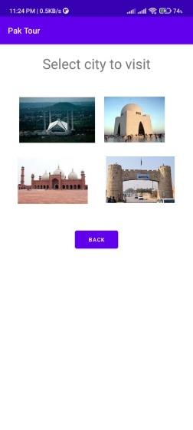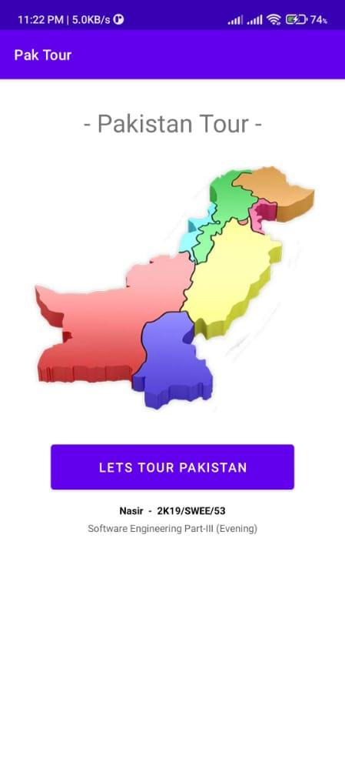

**Week 11**

**Task 20:** Create a Full app on any of the Topics below using **Navigation Drawer** in

Android Studio. Use the default Navigation Drawer in Android studio. Change the

Navigation menue Item and fragments to show your own content.

App Idea 4.

Quotes/Poems of Allma Iqbal

App Idea 5.

Famous Poet Poetry App,

App Idea 6.

App for Quranic Ayats on Various Topics

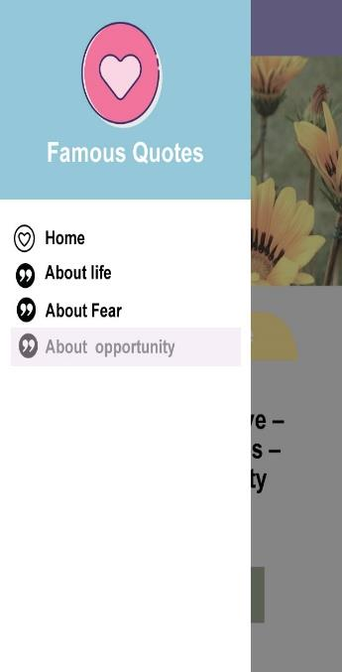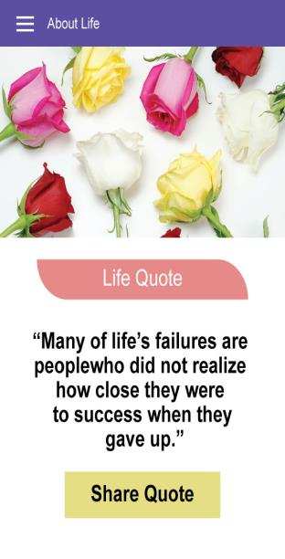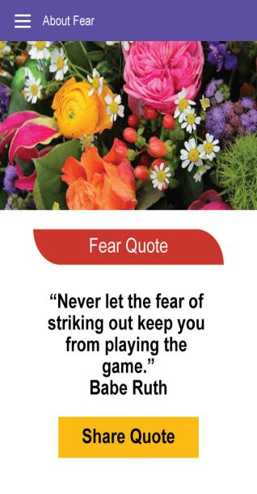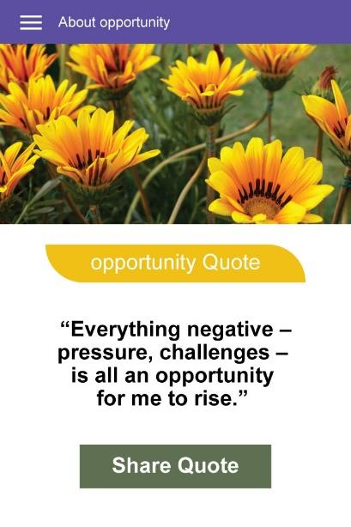

Week12:

**Task 19:** Create a Full app on any of the Topics below using **Navigation Drawer** in

Android Studio. Use the default Navigation Drawer in Android studio. Change the

Navigation menue Item and fragments to show your own content.

App Idea 1.

Navigation Drawer based Islamic Quotes App.

App Idea 2.

Famous Hadith on Multiple Tpics

App Idea 3.

Quotes of Quaid-e-azam

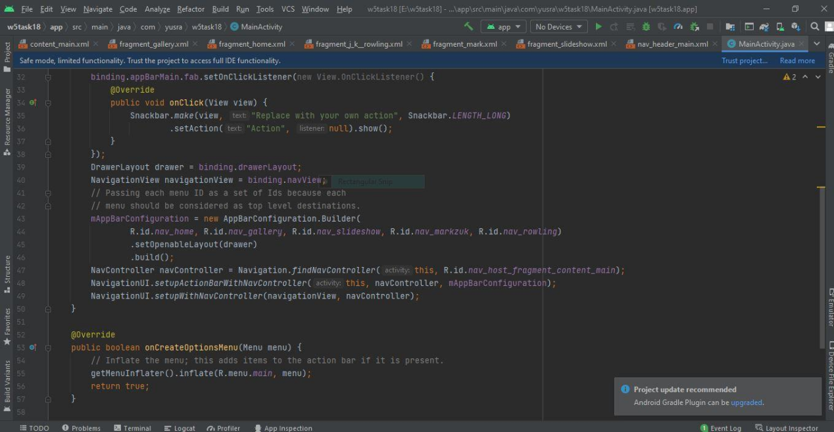

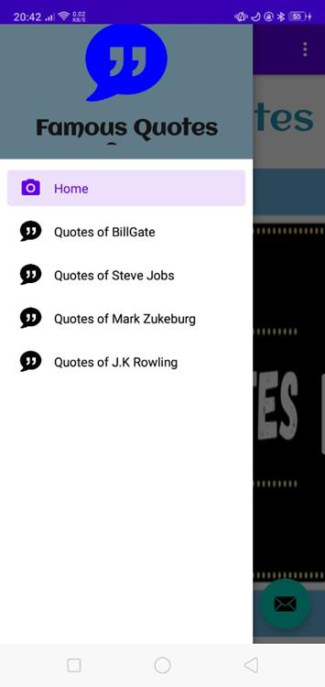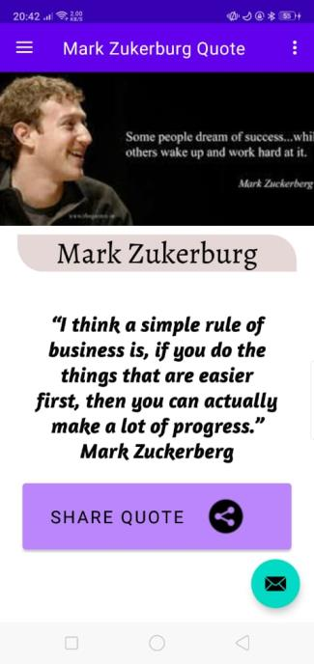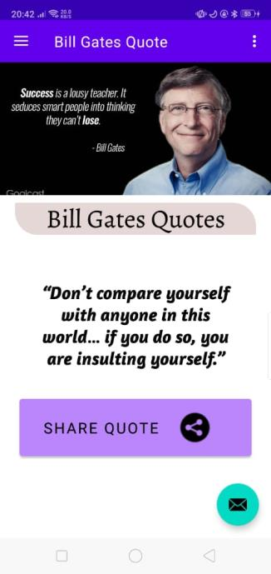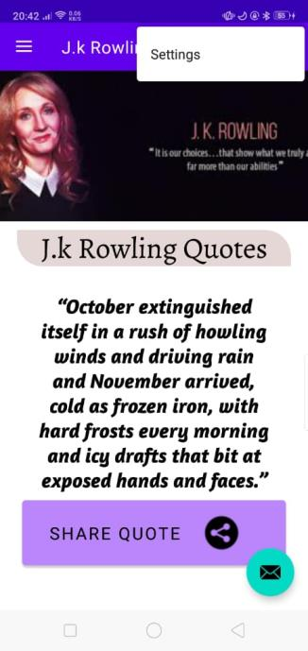

Week 13:

Task 25. Create a SQLite based simple CURD(Create Update Read Delete) App.

Create a SQLite based CRUD app that shows a simple form to the user and then

saves the user data in a Database.

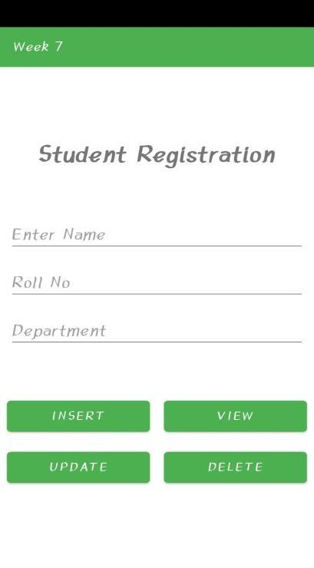

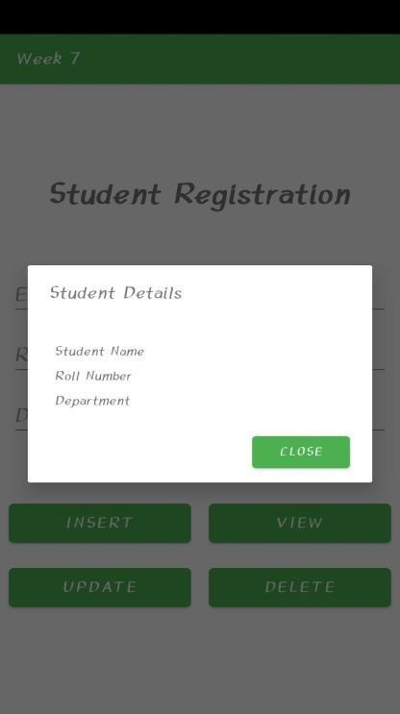

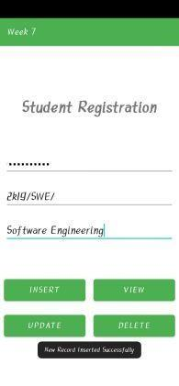

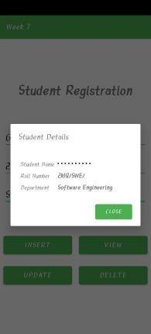

Task 26: Create a full Android App for “COVID-19 Student Registration App for

University “

Create an App for student to register their information about covid vaccination. Use the following GUI.

Save the Data in the SQLite Database and display it to the user once successfully saved.

